MASTERING GRAPH DSA IN PYTHON
Since you're starting DSA with basic knowledge of Python arrays and strings, I recommend learning Graphs step by step, from representing a graph in Python to solving advanced graph problems asked in technical interviews.
Your target should be to understand graph algorithms well enough to solve problems independently for Data Engineering, Data Science, and FAANG-level technical interviews.
Graphs can look intimidating initially, but most problems use a small set of recurring patterns: BFS, DFS, cycle detection, shortest paths, topological sorting, and minimum spanning trees.
1. What is a graph in DSA?
A graph is a data structure consisting of:
- Vertices (nodes): the objects or points.
- Edges: the connections between those objects.
For example, consider five cities connected by roads.
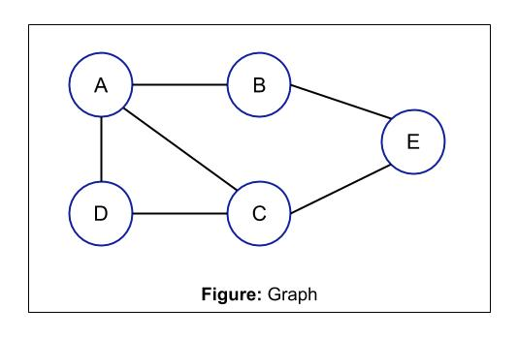
afteracademy.com
A graph represents relationships between objects, such as cities connected by roads, users connected by friendships, or computers connected by networks.
Graphs are used in many real-world applications:
Application | Graph representation
Social networks | People and their connections
Google Maps | Locations and roads
Data Engineering | Dependencies between pipeline tasks
Recommendation systems | Users, products and interactions
Computer networks | Devices and communication links
Knowledge graphs | Entities and their relationships
2. Understand the different types of graphs
Before writing algorithms, learn these graph types.
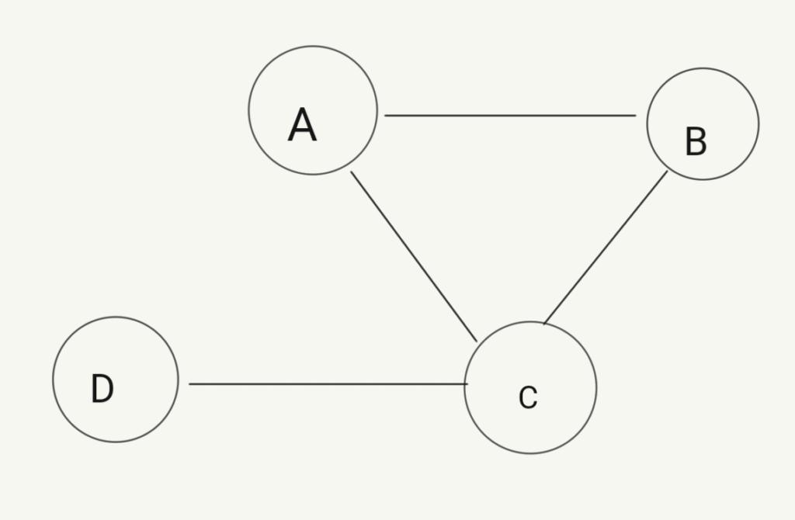
1. Undirected graph
An edge works in both directions. If A is connected to B, B is connected to A.
Example: Facebook friendships.
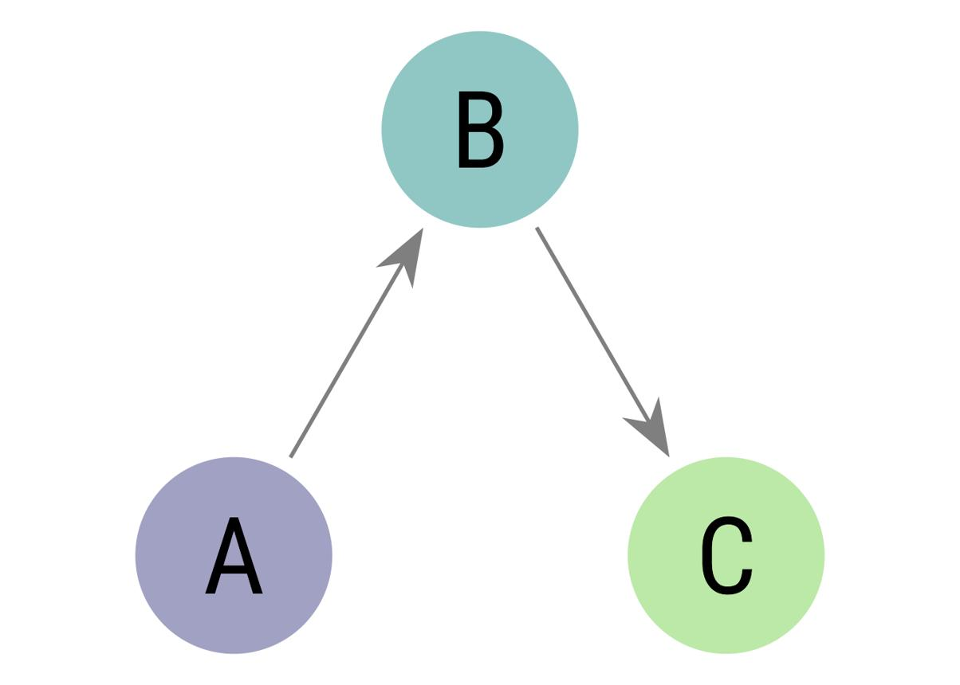
2. Directed graph
An edge has a direction, such as A → B.
Example: one task must run before another.
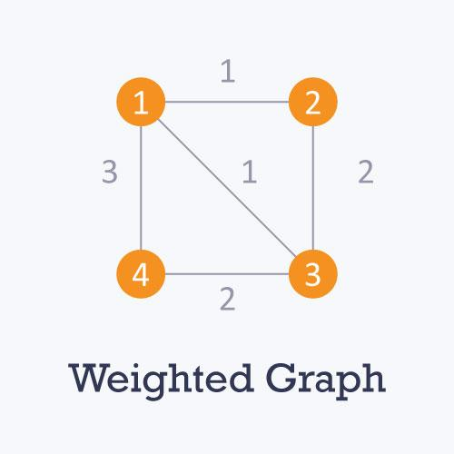
3. Weighted graph
Each edge has a cost, distance or weight.
Example: travel distances between cities.
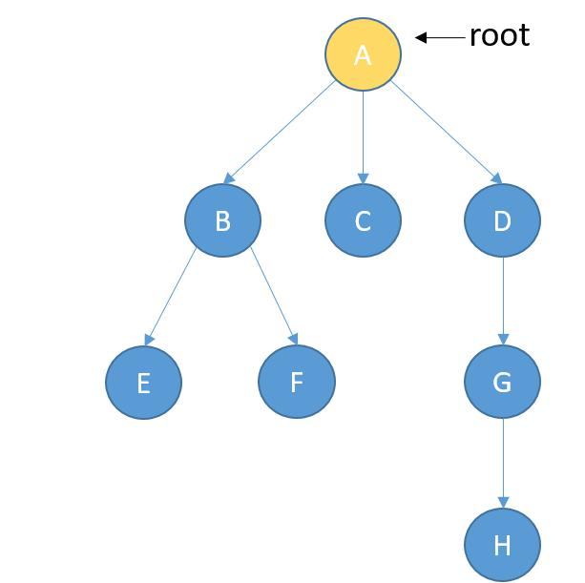
4. Tree
A connected, undirected graph with no cycles.
Example: hierarchical structures and directory systems.
Also learn these terms:
- Cycle: a path that returns to its starting vertex.
- Connected component: a group of vertices reachable from one another in an undirected graph.
- Degree: number of edges incident to a vertex in an undirected graph.
- Path: a sequence of connected vertices.
- DAG: a directed acyclic graph.
3. Learn graph representation in Python
This is your first practical milestone. You should be comfortable converting a graph into Python data structures.
Method 1: Adjacency list
An adjacency list stores the neighbors of each vertex. It is the most useful representation for most interview problems.
Example graph:
0 ----- 1
| |
| |
2 ----- 3
Python code:
graph = { 0: [1, 2], 1: [0, 3], 2: [0, 3], 3: [1, 2]}print(graph[0])print(graph[1])
Output:
[1, 2]
[0, 3]
For an undirected graph, add each edge in both directions.
n = 4edges = [ (0, 1), (0, 2), (1, 3), (2, 3)]graph = [[] for _ in range(n)]for u, v in edges: graph[u].append(v) graph[v].append(u)print(graph)
Output:
[[1, 2], [0, 3], [0, 3], [1, 2]]
Time complexity to build the adjacency list: \(O(V+E)\).
Here, \(V\) means the number of vertices and \(E\) means the number of edges.
Method 2: Adjacency matrix
An adjacency matrix uses a two-dimensional array. A value of 1 means an edge exists.
n = 4edges = [ (0, 1), (0, 2), (1, 3), (2, 3)]matrix = [[0] * n for _ in range(n)]for u, v in edges: matrix[u][v] = 1 matrix[v][u] = 1for row in matrix: print(row)
Output:
[0, 1, 1, 0]
[1, 0, 0, 1]
[1, 0, 0, 1]
[0, 1, 1, 0]
Representation | Space | Best use
Adjacency list | \(O(V+E)\) | Sparse graphs and most DSA problems
Adjacency matrix | \(O(V^2)\) | Dense graphs and quick edge-existence checks
Your goal: Build both representations without referring to notes.
4. Master BFS — Breadth-First Search
BFS visits vertices level by level, starting from a source vertex.
It uses a queue, which follows First In, First Out (FIFO).
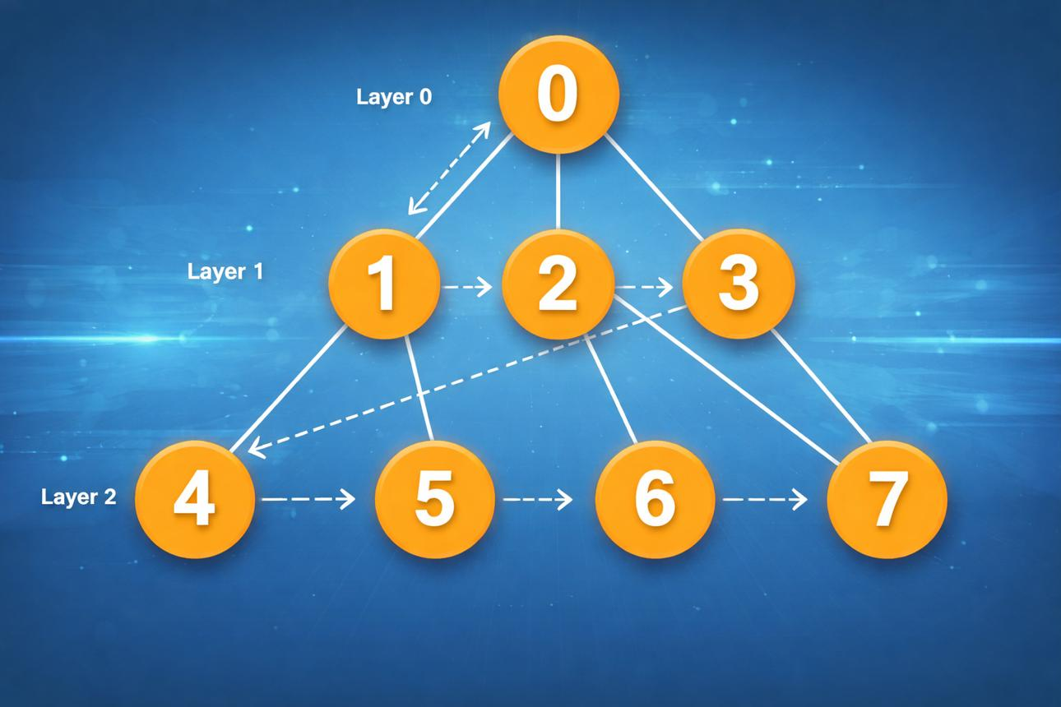
ru.hexlet.io
BFS explores all immediate neighbors before visiting vertices farther away.
Python implementation
from collections import dequedef bfs(graph, start): visited = {start} queue = deque([start]) order = [] while queue: node = queue.popleft() order.append(node) for neighbor in graph[node]: if neighbor not in visited: visited.add(neighbor) queue.append(neighbor) return ordergraph = { 0: [1, 2], 1: [0, 3], 2: [0, 3], 3: [1, 2]}print(bfs(graph, 0))
Output:
[0, 1, 2, 3]
The exact traversal order can vary with neighbor ordering.
Complexity: \(O(V+E)\) time and \(O(V)\) auxiliary space.
BFS problems to practice
- BFS Traversal of a Graph
- Level Order Traversal of a Binary Tree
- Number of Islands
- Rotting Oranges
- Shortest Path in an Unweighted Graph
- 01 Matrix
- Word Ladder
BFS is especially important because it finds shortest paths in unweighted graphs.
5. Master DFS — Depth-First Search
DFS explores as far as possible along one path before backtracking.
You can implement it using recursion or an explicit stack.
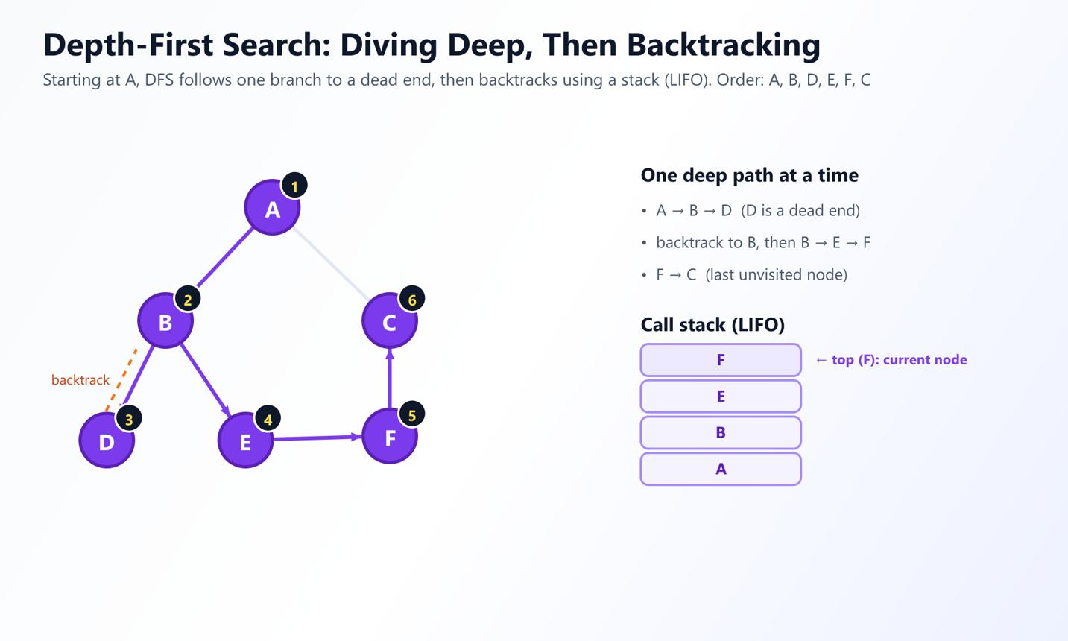
learngraphtheory.org
DFS follows a branch deeply and then returns to explore other branches.
Recursive DFS in Python
def dfs(graph, start): visited = set() order = [] def explore(node): visited.add(node) order.append(node) for neighbor in graph[node]: if neighbor not in visited: explore(neighbor) explore(start) return ordergraph = { 0: [1, 2], 1: [0, 3], 2: [0, 3], 3: [1, 2]}print(dfs(graph, 0))
Output:
[0, 1, 3, 2]
DFS order depends on neighbor ordering.
Iterative DFS
def dfs_iterative(graph, start): visited = set() stack = [start] order = [] while stack: node = stack.pop() if node in visited: continue visited.add(node) order.append(node) for neighbor in reversed(graph[node]): if neighbor not in visited: stack.append(neighbor) return order
Both BFS and DFS typically run in \(O(V+E)\) time when using adjacency lists.
DFS problems to practice
- DFS Traversal
- Number of Provinces
- Flood Fill
- Number of Islands
- Clone Graph
- Find Connected Components
- Detect a Cycle in an Undirected Graph
- Detect a Cycle in a Directed Graph
Important: Learn the difference between a global visited set and the recursion path currently being explored. This distinction becomes essential for cycle detection.
6. Complete graph DSA syllabus: beginner to advanced
The following is the sequence I recommend. Do not jump directly to advanced algorithms before you can comfortably implement BFS and DFS.
Level 1 — Graph fundamentals
Weeks 1–2
Graph terminology, directed/undirected and weighted graphs, adjacency lists, matrices, BFS, DFS and connected components.
Practice: 10–15 problems.
Level 2 — Graph traversal and cycles
Weeks 3–4
Connected components, cycle detection, bipartite graphs, multi-source BFS and grid traversal.
Practice: 12–15 problems.
Level 3 — Shortest paths
Weeks 5–6
BFS shortest paths, Dijkstra's algorithm, Bellman–Ford and Floyd–Warshall.
Practice: 10–12 problems.
Level 4 — Directed graphs and dependencies
Weeks 7–8
Topological sorting, Kahn's algorithm, cycle detection in directed graphs and strongly connected components.
Practice: 10–12 problems.
Level 5 — Minimum spanning trees and DSU
Weeks 9–10
Disjoint Set Union, path compression, union by rank/size, Kruskal's and Prim's algorithms.
Practice: 8–10 problems.
Level 6 — Advanced graph algorithms
Weeks 11–14+
Tarjan's bridges and articulation points, strongly connected components, network flow, bipartite matching, shortest paths with constraints and graph problems combined with DP.
Practice: 10–15 problems.
This is an intensive study plan. Spend extra time on any stage where you cannot derive the solution without assistance.
7. Shortest path algorithms you must know
Choosing the correct shortest-path algorithm is an important interview skill.
Algorithm | When to use it | Typical complexity
BFS | Unweighted graphs or equal edge costs | \(O(V+E)\)
Dijkstra | Non-negative edge weights | \(O((V+E)\log V)\) with a binary heap
Bellman–Ford | Negative edges; detects reachable negative cycles | \(O(VE)\)
Floyd–Warshall | Shortest paths between all pairs | \(O(V^3)\)
Example: Dijkstra's algorithm in Python
import heapqdef dijkstra(graph, start): distances = {node: float("inf") for node in graph} distances[start] = 0 heap = [(0, start)] while heap: distance, node = heapq.heappop(heap) if distance != distances[node]: continue for neighbor, weight in graph[node]: new_distance = distance + weight if new_distance < distances[neighbor]: distances[neighbor] = new_distance heapq.heappush( heap, (new_distance, neighbor) ) return distancesgraph = { "A": [("B", 4), ("C", 1)], "B": [("A", 4), ("C", 2), ("D", 1)], "C": [("A", 1), ("B", 2), ("D", 5)], "D": [("B", 1), ("C", 5)]}print(dijkstra(graph, "A"))
Output:
{'A': 0, 'B': 3, 'C': 1, 'D': 4}
The shortest distance from A to D is 4, through A → C → B → D.
Notice that Dijkstra is not suitable for graphs with negative edge weights.
8. Topological sorting — especially useful for Data Engineering
Topological sorting gives a valid order for executing tasks when dependencies form a directed acyclic graph (DAG).
For example:
Extract Data → Clean Data → Transform Data → Load Data
This is directly relevant to ETL pipelines, task schedulers and dependency management.
Python implementation using Kahn's algorithm
from collections import dequedef topological_sort(graph, n): indegree = [0] * n for node in graph: for neighbor in graph[node]: indegree[neighbor] += 1 queue = deque( node for node in range(n) if indegree[node] == 0 ) order = [] while queue: node = queue.popleft() order.append(node) for neighbor in graph[node]: indegree[neighbor] -= 1 if indegree[neighbor] == 0: queue.append(neighbor) if len(order) != n: return None # The graph contains a directed cycle. return ordergraph = { 0: [1, 2], 1: [3], 2: [3], 3: []}print(topological_sort(graph, 4))
One valid output is:
[0, 1, 2, 3]
Time complexity: \(O(V+E)\).
The order may differ when multiple tasks are independent.
9. Disjoint Set Union (DSU) and minimum spanning trees
DSU, also called Union-Find, efficiently tracks which connected component a vertex belongs to.
Learn these operations:
- find(x): find the representative of the component.
- union(a, b): merge two components.
- Path compression: flatten paths during find.
- Union by size or rank: attach smaller trees beneath larger ones.
After that, learn:
- Kruskal's algorithm: sort edges by weight and use DSU to avoid cycles.
- Prim's algorithm: grow a minimum spanning tree by choosing the lowest-cost edge connecting the current tree to a new vertex.
These algorithms are important for network design, connecting locations at minimum cost and graph interview problems.
10. A curated list of 40 graph problems
Use this list as a progression, rather than attempting every problem in a single week.
# | Problem | Main concept
1 | Graph Representation | Adjacency list
2 | BFS Traversal | BFS
3 | DFS Traversal | DFS
4 | Number of Provinces | Components
5 | Flood Fill | DFS/BFS
6 | Number of Islands | Grid traversal
7 | Max Area of Island | DFS
8 | Rotting Oranges | Multi-source BFS
9 | Is Graph Bipartite? | Coloring
10 | Cycle in Undirected Graph | DFS/BFS
11 | Cycle in Directed Graph | DFS states
12 | Clone Graph | Traversal and mapping
13 | Shortest Path in an Unweighted Graph | BFS
14 | 01 Matrix | Multi-source BFS
15 | Word Ladder | BFS
16 | Open the Lock | State-space BFS
17 | Course Schedule | Topological sort
18 | Course Schedule II | Topological ordering
19 | Find Eventual Safe States | Directed graph analysis
20 | Alien Dictionary | Topological sort
21 | Network Delay Time | Dijkstra
22 | Path With Minimum Effort | Dijkstra
23 | Cheapest Flights Within K Stops | Constrained shortest path
24 | Bellman–Ford | Negative weights
25 | Floyd–Warshall | All-pairs shortest path
26 | Min Cost to Connect All Points | MST
27 | Connecting Cities With Minimum Cost | MST
28 | Redundant Connection | DSU
29 | Accounts Merge | DSU
30 | Number of Operations to Make Network Connected | DSU
31 | Critical Connections in a Network | Bridges
32 | Articulation Points | DFS discovery/low times
33 | Strongly Connected Components | Kosaraju or Tarjan
34 | Maximum Flow | Flow networks
35 | Bipartite Matching | Matching algorithms
36 | Reconstruct Itinerary | Eulerian path
37 | Evaluate Division | Weighted graph traversal
38 | All Paths From Source to Target | DFS/backtracking
39 | Shortest Path in a Binary Matrix | BFS
40 | Traveling Salesperson Problem | Bitmask DP
You can find many of these by their exact names on LeetCode and GeeksforGeeks.
- LeetCode graph problems
- GeeksforGeeks graph tutorials
11. Your daily practice routine
If you have 60–90 minutes per day, follow this structure.
15 minutes — Learn
Study one algorithm and trace it on a small graph.
25 minutes — Implement
Write the algorithm from scratch in Python.
30 minutes — Solve
Attempt one problem independently; try a second if time allows.
10 minutes — Revise
Record mistakes, complexity and the reason you chose the algorithm.
If a problem takes longer than expected, do not rush. Read a hint, understand the idea, close the solution, and reproduce it yourself.
12. Track your progress
Use this checklist to track the major milestones as you work through the roadmap.
Graph DSA roadmap
0 of 6 milestones
Weeks 1–2
Graph representation, BFS and DFS
Weeks 3–4
Components, cycles, grids and bipartite graphs
Weeks 5–6
BFS shortest paths, Dijkstra and Bellman–Ford
Weeks 7–8
Topological sorting and strongly connected components
Weeks 9–10
DSU, Kruskal and Prim
Weeks 11–14+
Bridges, flow, matching and advanced problems
Reset progress
13. When are you ready for graph interview questions?
You should be able to:
- Build adjacency lists and matrices without help.
- Implement BFS and DFS from memory.
- Explain visited sets, queues, stacks and recursion.
- Detect cycles in directed and undirected graphs.
- Recognize when BFS or Dijkstra is appropriate.
- Implement topological sorting and DSU.
- Analyze time and space complexity.
- Solve unseen medium-level problems by deriving the algorithm rather than recalling memorized code.
For Data Engineering interviews, prioritize traversal, dependency graphs, topological sorting, shortest paths and DSU. For general software engineering interviews, also develop strong skills in grid graphs, cycle detection and advanced graph patterns.
My recommendation: Start with graph representation, BFS and DFS. Solve five to ten basic traversal problems before learning shortest paths. Once you can implement BFS and DFS independently, the rest of graph DSA becomes much easier to organize and understand.

